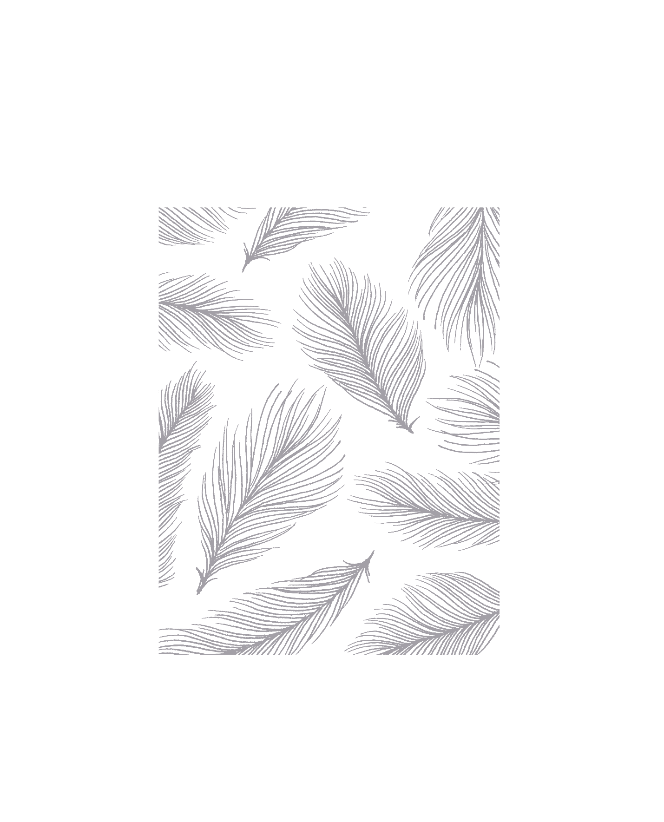

PHYS 212

Electricity & Magnetism

Lanxiao Bai

University of Illinois at Urbana-Champaign

Electricity:

Coulomb's Law: =

Electric Field:

* Point charge source:
* Infinite line charge source:

Electric Flux:

* Property:
  + 电场线密的地方场强大，电场线疏的地方场强小
  + 电场线起于正电荷或无穷远，止于负电荷或无穷远

Gauss's Law:

* Spherical Shell:

* Solid Sphere:

* Conductor:
* Solid Infinite Cylindrical Conductor:
* Infinite Sheet of Charge:

Electric Potential Energy:



Coulomb Force 是有心力，因此可以证明 Coulomb Force 是保守力, 即：

* 能量守恒定律：

Electric Potential:

* + Point Charge Source:
  + Cartesian:
  + Spherical:
  + Cylindrical:
  + Property:
    - 电场线总是垂直于等势面
    - 等势面密的地方电势差大，电场强；等势面疏的地方电势差小，电场弱

Conductor

* Property:
  + 因为导体内电荷可以自由移动，因此其内部
  + Thus,
  + 因此，导体内部每一点都等势，电场线都与导体表面相垂直
  + 导体内部的空腔场强处处为0
  + 导体曲率高的地方面电荷密度高，曲率低的地方面电荷密度低

Capacitance:

* Capacitor: Separated charged conductor to store energy

  + Energy density
* ,
* Dielectric Constant:
* Capacitor in parallel
* Capacitor in series

Directed Current Circuit:

Electric current:

Current density:

Ohm's law:

Resistor: Obey to Ohm's law

Resistance:

Resistor in Series:

Resistor in Parallel

|  |  |  |
| --- | --- | --- |
|  | Resistor | Capacitor |
| Series |  |  |
| Parallel |  |  |

Power:

Kirchhoff's Rules:

* Kirchhoff's Voltage Rule:
* Kirchhoff's Current Rule:

Ideal Battery

Real Battery

RC Circuit



* Boundary Condition

|  |  |
| --- | --- |
|  |  |
|  |  |



* Boundary Condition

|  |  |
| --- | --- |
|  |  |
|  |  |

* Time constant:
* Power in circuit:
* Energy in capacitor:
* Power of capacitor:

Magnetism:

Coulomb's Law:

Magnetic Field:

Magnetic Potential of Magnetic Dipole:

Magnetic Flux Density:

Lorentz force:



Magnetic Force on a straight charge-carrying wire:

Magnetic Force on a curved charge-carrying wire:

Force on a current loop:

Torque on a current loop:

Considering Dipole Moment:

Potential Energy:

Biot-Savart Law:

Straight Current-Carrying Wire:

Force between two parallel conductors:

Force along axis of Current Loop:

Ampere’s Law

Magnetic Field inside a wire

Infinite Sheet of current